-Template-
University Logo
UI GreenMetric World University Rankings (UIGWURN) Report 2021
Please complete this report according to your activities. This report will be presented by national coordinator(s) at UIGWURN Steering Committee Meeting.
Country : …
National Coordinator (s) : …

- General Report
- Activities:
- Shaping Global Higher Education and Research in Sustainability
- Creating Global Sustainability Leaders
- Partnering on Solutions to Sustainability Challenges
- Table Activities

No. | Date | Activity | Report | Photo
1. |  |  | Number of Participants, Result, etc.
Etc.

- Challenges and Future Plans
Example:
- National Workshop of UI GreenMetric for …. Universities on (the date of event), 2020
- Other plans

- Comments

Prepared by…

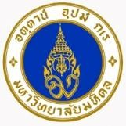
-Example-
UI GreenMetric World University Rankings (UIGWURN) Report 2020
Country : Thailand
National Coordinator (s) : Mahidol University

General Report
Mahidol University has joined UI GreenMetric World University Ranking since 2012. We systemized the activities on the sustainable development and on the creation of the national partnership. On 16th December 2015, Mahidol University establishes and inks memorandum of understanding (MOU) on Sustainable University Network of Thailand (SUN Thailand) with 15 universities. The aim of SUN Thailand is creating collaboration on sustainable university, sharing and learning on the best practice on sustainable development, and providing sustainable development models to other sectors of society. In 2020, SUN Thailand has 34 university members and now we are under council of university presidents of Thailand. Among the main steps was the elaboration of the sustainable policy of the University and organization of the national conference of sustainable university.

Activities:
  - Shaping Global Higher Education and Research in Sustainability
SUN Thailand organize of the annual conference on sustainability in higher education. There are many interest papers on the 4th Annual Conference “From SDGs to BCG” at Northern Science Park - Chiang Mai University” on 12 – 13 December 2019. The main theme of this conference is “From SDGs to BCG: The Sustainable Strategic Plan for Thailand’s Higher Education”. The sub theme includes 1. sustainable Development Goals 2. smart campus 3. bio & cultural diversity economy 4.circular economy 5.green economy 6.upcycling economy 7.reduce, reuse, recycle, renewable 8. innovation & transforming. Moreover, the panel discussion is “The Sustainable Agenda of Thailand’s Higher Education”.

Creating Global Sustainability Leaders
SUN Thailand encourage not only academic staff or students but also the supporting staff to participate and submit the paper to the annual conference of SUN Thailand. SUN Thailand also distributes and shares the best practice on sustainability among the member universities. The best practice on the 4th Annual Conference “From SDGs to BCG: The Sustainable Strategic Plan for Thailand’s Higher Education” is
- Chiang Mai University: Integrated Biomass Management Center
- King Mongkut’s University of Technology North Bangkok: Wastewater treatment of Central Cafeteria for environmental learning center
- Thammasat University: Kayaking for Chao Phraya The best practice on Staff project challenge 2020
- Renewable Energy: Water resource management the case study of the sufficient check dam at Ban San Sai Ngam, Teng, Chiangrai of Siam University.
- Traffic and smart system: Road Safety Culture initiation: A case study in KMUTT of King Mongkut’s University Technology Thonburi (KMUTT)
- Waste Management: Waste Management in Student’s Activities of King Mongkut’s University of Technology Thonburi (KMUTT)
- Green building, landscape and environment: Puey Ungphakorn Centenary Hall of Thammasat University

Partnering on Solutions to Sustainability Challenges
SUN Thailand is the partner with Asian Sustainable Campus Network (ASCN) which consists of Campus Sustainability Network in Japan (CAS-Net JAPAN), Korean Association for Green Campus Initiative (KAGCI), and China Green University Network (CGUN). In 2018, ASCN sign MOU with EAUC

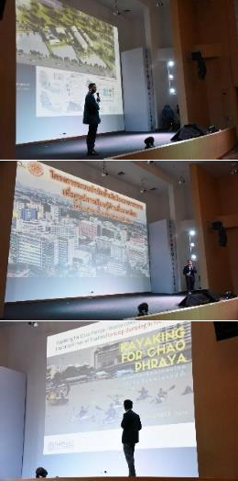
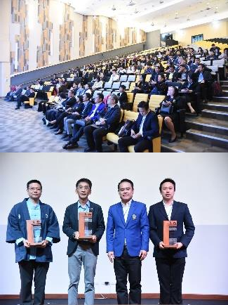
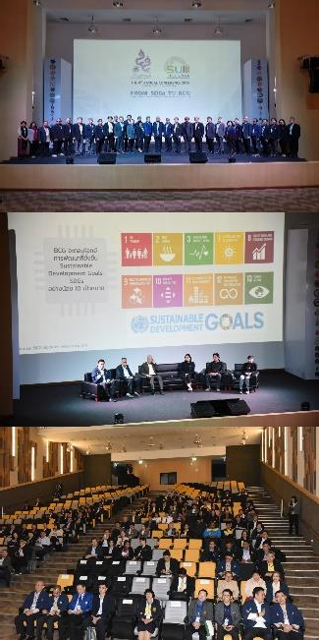
Table Activities

No. | Date | Activity | Report | Photo
1. | 12-13  December 2019 | The 4th Annual  Conference 2019 “From SDGs to BCG”  at Northern Science Park - Chiang Mai University | More than 200 participants from 34  universities (SUN Thailand’s member) There are 2 panel discussion on  - SUN Thailand from the beginning to the future and  - The Sustainable Agenda of Thailand’s Higher Education includes 4 topics;  - Thai University Sustainable Planning Development)  - Smart city Thailand  - Circular Economy  - SDGs & BCG for Startup
2. | 13  December 2019 | Staff Project  Challenge 2020 | There are 17 projects from 9 universities  which pass the selection round to present on the final round to exchange of knowledge from model projects on institutional sustainability. The winner project each topic are  - Renewable Energy: Water resource management the case study of the sufficient check dam at Ban San Sai Ngam, Teng, Chiangrai of Siam University.  - Traffic and smart system: Road Safety Culture initiation: A case study in KMUTT of King Mongkut’s University Technology Thonburi (KMUTT)  - Waste Management: Waste Management in Student’s Activities of King Mongkut’s University of Technology Thonburi (KMUTT)  - Green building, landscape and environment: Puey Ungphakorn Centenary Hall of Thammasat University

No. | Date | Activity | Report | Photo
3. | 13  December 2019 | Student Project  Challenge 2020 “Make Sustainable Impact for Green University”  (6 projects) | There are 6 student projects from 5  Universities pass selected round to present on the 4th Annual Conference 2019 “From SDGs to BCG”  The 1st prize is “Making Compost from aquatic garbage”, Siam University.  The 2nd prize is “Responsible Waste Producer”, Chiang Mai University.  The 3rd prize is “Thammasat Zero Waste: Change for All”  And 3 consolation prizes for  - Siimsi Waste, Kasetsart University  - Prebiotor, Chiang Mai University.  - KMUTT student activities arrangement under zero emission concept. | 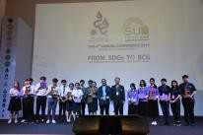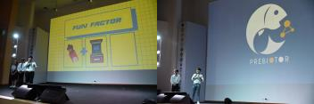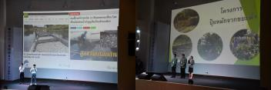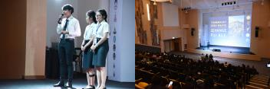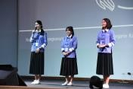
4. | 5 - 6  March 2020 | Sustainable  University Network of Thailand Meeting 1st/2020 at King Mongkut's Institute of Technology Ladkrabang, Prince of Chumphon Campus. | 34 universities join the first meeting of SUN  Thailand at King Mongkut's Institute of Technology Ladkrabang, Prince of Chumphon Campus. | 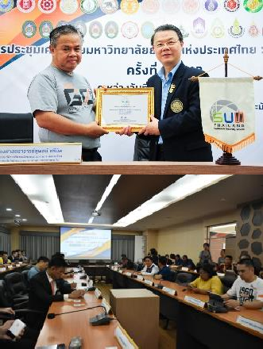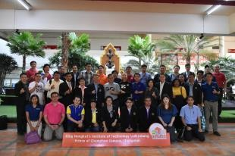
5. | 17 June  2020 | Webinar “National  Sustainability Leaders Meeting 2020” organized by UI GreenMetric World Universities Rankings, IPB University and Universitas Indonesia. | Assoc. Prof. Kitikorn Charmondusit, Ph.D.  (Vice President for Environment and Sustainable Development, Mahidol University, Thailand) as a keynote speaker present in “The Urgency of Sustainability Leader in University: The Experience of Mahidol University, Thailand” | 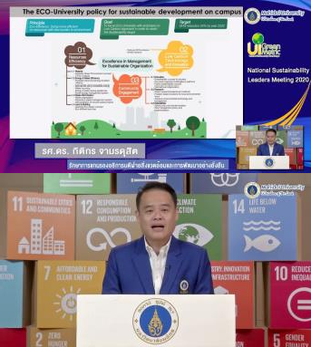

No. | Date | Activity | Report | Photo
6. | 17 July  2020 | Sustainable  University Leader towards UI GreenMetric World University Rankings Webinar | Mahidol University organize “Sustainable  University leader towards UI GreenMetric World University Rankings” online symposium to enhance sustainable development in higher education. This symposium aims to share current management experience in sustainable development among the universities.  More than 80 participants from Thai and Indonesia universities attend this webinar via Zoom, LIVE Facebook MU SDGs and  YouTube. | 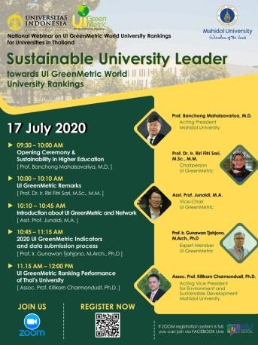
7. | 27-28  August 2020 | Sustainable  University Network of Thailand Meeting 2nd /2020 at Naresuan University | 34 universities join the second meeting of  SUN Thailand at Naresuan University | 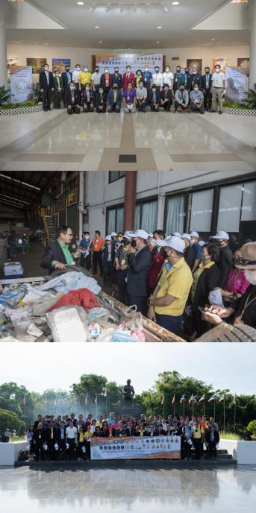
8. | Since  2019 | Web page on SUN  Thailand | Created and maintained the web page on  SUN Thailand. https://sunthailand.net/ | 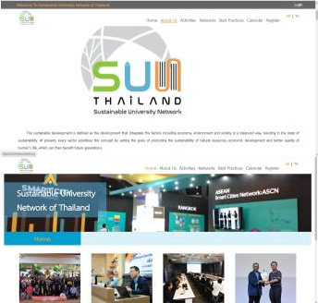
9. | October  2019 to  July 2020. | Public relations for  “Mahidol No Plastic Cup” | This project expanded from single-use  plastic reduction activity. This project aims to raise awareness of reducing single-use plastic which leading to plastic waste reduction align with Eco University policy. The project resulted from the data collected in the period of October to December 2019 | 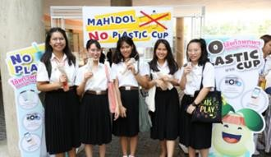

No. | Date | Activity | Report | Photo
 |  |  | was found that the reduction of the plastic  cup is 14,933 which calculated for GHGs is  5.08 ton CO₂e and calculated for GHGs is  20.32 per year of greenhouse gases emissions reduction. Moreover, there also earned 390,052.76 baht from selling recycled plastic wastes from October 2019 to July 2020. | 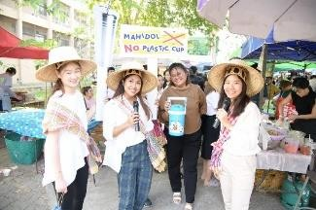
10. | 28  January 2020 | PM 2.5 MU  Exhibition | PM 2.5 MU Exhibition aims to promote  understanding the effect of particulate matter (PM2.5) on environment and health, ways to protect health against PM2.5 and also ways to reduce the amount of particle. Faculty of environment and natural resources, Division of Physical systems and Environment and Division of Academic Affairs Mahidol University were collaborating on this exhibition. | 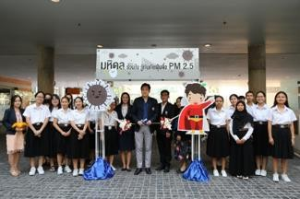
11. | 5 June  2020 | World Environment  Day 2020:  Biodiversity | World Environment Day 2020: Biodiversity  World environment day is celebrated on June 5 every year, focusing on pressing environmental issues. This year the theme is “Biodiversity”. To achieve the eco- university policy, division of Physical systems and Environment, Mahidol University organized tree planting activity at Mahidol University Library and Knowledge Center on May 25, 2020 and June 5, 2020 by the practice of social distancing. There are 61 participants from 28 faculties. | 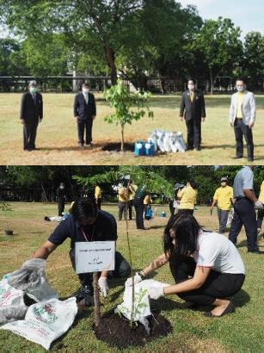
12. | 5 June  2020 | New Normal  adaptation of physical education and services to support the school during the crisis COVID-19. Webinar via Zoom | Mahidol University organize Webinar “New  Normal adaptation of physical education and services to support the school during the crisis COVID-19”  More than 400 participants from 75 organization attend this webinar | 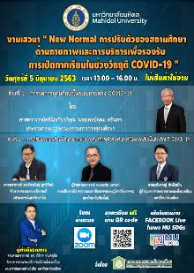  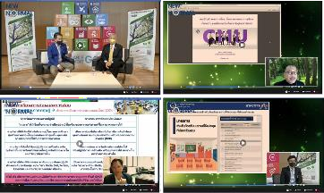

No. | Date | Activity | Report | Photo
13. | 23 July  2020 | Mahidol Innovation  for Campus Sustainability 2020 | Innovation for Campus Sustainability  Project is an activity contest for all student to design or create of an innovation towards sustainable university. The project aims to find the best innovation that apply the knowledge of sustainable development on three aspects including economic, social and environment and to strengthen Mahidol students to be a person who has creativity for innovation which align with Thailand 4.0. 9 students team present in the proposal presentation round. | 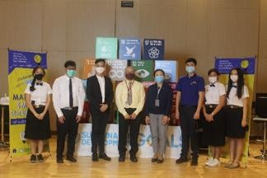
14. | 6 August  2020 | Cooperation of  Recyclable Waste Bank | Mahidol University cooperates with PTT  Global Chemical Public Company Limited to launch the “Think Cycle Bank” project to create a solid waste management network which enhance knowledge and understanding of waste management process that can convert waste into economic value. There are 22 pilot schools in Rayong province, 8 pilot schools in Nakhon Pathom province and 3 pilot schools in Buriram province which have been implemented the Think Cycle Bank to create a good quality of life. | 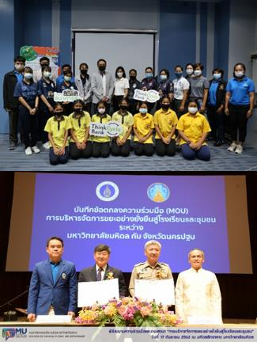

- Challenges and Future Plans
  - Sustainable University Network of Thailand Meeting 3rd /2020 at Prince of Songkla University, Phuket Campus on 8-10 October 2020
  - The 5th Annual Conference of Sustainable University Network of Thailand 2020 at King Mongkut’s University Technology Thonburi on 3-4 December 2020
  - SUN Thailand is host to organize The 2nd Asian sustainable campus network (ASCN) 2020 in Thailand
  - Development the project and activities on environment and sustainable development.
  - Active involvement of the universities into SUN Thailand to build network and partnership driving sustainability in education sector as a role model for other sectors of Thai society.
  - Active involvement of the students into the projects on sustainability.
  - Collaboration with the partner universities around the world and international network.
  - Promote sustainable development in Thai higher education institutions.

Prepared by Assoc. Prof. Kitikorn Charmondusit, Ph.D.
Vice President for Environment and Sustainable Development

