-Template-
University Logo
UI GreenMetric World University Rankings (UIGWURN) Report 2022
Please complete this report according to your activities. This report will be presented by national coordinator(s) at UIGWURN Steering Committee Meeting.
Country : …
National Coordinator (s) : …

- General Report
- Activities:
- Shaping Global Higher Education and Research in Sustainability
- Creating Global Sustainability Leaders
- Partnering on Solutions to Sustainability Challenges
- Table Activities

No. | Date | Activity | Report | Photo
1. |  |  | Number of Participants, Result, etc.
Etc.

- Challenges and Future Plans
Example:
- National Workshop of UI GreenMetric for …. Universities on (the date of event), 2020
- Other plans

- Comments

Prepared by…

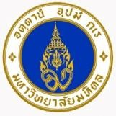
-Example-

UI GreenMetric World University Rankings (UIGWURN) Report 2021
Country : Thailand
National Coordinator (s) : Mahidol University

General Report
Mahidol University has joined UI GreenMetric World University Ranking since 2012. We systemized the activities on the sustainable development and on the creation of the national partnership. On 16th December 2015, Mahidol University establishes and inks memorandum of understanding (MOU) on a Sustainable University Network of Thailand (SUN Thailand) with 15 universities. The aim of SUN Thailand is creating collaboration on sustainable university, sharing and learning on the best practice for sustainable development, and providing sustainable development models to other sectors of society. In 2021, SUN Thailand has 36 university members and now we are under a council of university presidents of Thailand. Among the main steps was the elaboration of the sustainable policy of the University and organization of the national conference of sustainable university.

Activities:
  - Shaping Global Higher Education and Research in Sustainability
SUN Thailand organize the annual conference on sustainability in higher education. There are many interesting papers on the 5th Annual Conference “Sustainable Campus by SDGs in Actions” on 3-4 December 2020. The main theme of this conference is “Sustainable Campus by SDGs in Actions: Best Practice Sharing & Learning Experience”. The sub theme includes 1. SEP for SDGs 2. Sustainable Education 3. Sustainable Energy 4. Sustainable Environment 5. Sustainable Health and Safety 6. Sustainable Mobility or Sustainable Transportation. Moreover, the panel discussion is “Educational Sustainability & Educational Reform in Thai University”.

Creating Global Sustainability Leaders
SUN Thailand encourages not only academic staffs or students, but also the supporting staffs to participate and submit the paper to the annual conference of SUN Thailand. SUN Thailand also distributes and shares the best practice on sustainability among the member universities in the 5th Annual Conference: Sustainable Campus by SDGs in Actions.

Partnering on Solutions to Sustainability Challenges
SUN Thailand is the partner with Asian Sustainable Campus Network (ASCN) which consists of the Campus Sustainability Network in Japan (CAS-Net JAPAN), Korean Association for Green Campus Initiative (KAGCI), and China Green University Network (CGUN). In 2018, ASCN sign MOU with EAUC

Table Activities

No. | Date | Activity | Report | Photo
1. | 8-9 October  2020 | Sustainable University Network of Thailand Meeting 3rd/2020 at Pearl Hotel, Phuket. | Assoc. Prof. Kitikorn Charmondusit, Ph.D. the Vice President for  Environment and Sustainable Development, Mahidol University, Thailand had a meeting with the representative from 34 universities of Sustainable University Network Thailand (SUN Thailand) to exchange knowledge on how to prepare data for UI GreenMetric World University Rankings, as well as visit the exhibition on sustainability of Prince of Songkla University, all five campuses. Furthermore, also study tour about four sustainable communities in Phuket including Ban BoRae, Ban Panwa, Manikkram and Phuket old town community. | 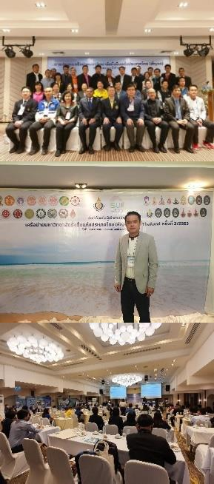
2. | 30  November- 4 December  2020 | Mahidol Sustainability Week 2020 | Mahidol University  organized Mahidol Sustainability Week 2020 Exhibition was held at the Mahidol Learning Center, the aims of this exhibition are to communicated knowledge of the 17 Sustainable Development Goals of the United Nations (UN) and disseminated program for sustainability of Mahidol University to students and staffs. This activity consisted of the following sub activities: MU SDGs Talk and Mahidol  Sustainable Development Goals Conference. | 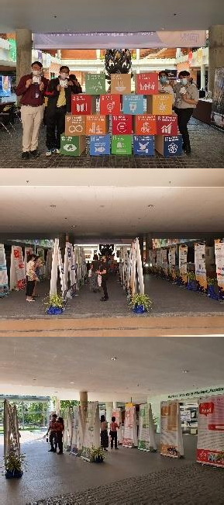

No. | Date | Activity | Report | Photo
3. | 1 December  2020 | MU SDGs  Talk 2020 | MU SDGs Talk was the forum for exchange the knowledge on sustainable health, sustainable society and sustainable economy or business. This activity was honored by 2 keynote speakers from Mahidol University, Thailand, including Assoc. Prof. Kraichat Tantrakarnapa, Ph.D., the Deputy Dean for Physical Resource and Environment, Faculty of Tropical Medicine of Mahidol University presented in the topic “Environment and Health” and Assoc. Prof. Sooksan Kantabutra, Ph.D., the Deputy Dean for Research, College of Management, Mahidol University presented in the topic “Sustainable Economy”. | 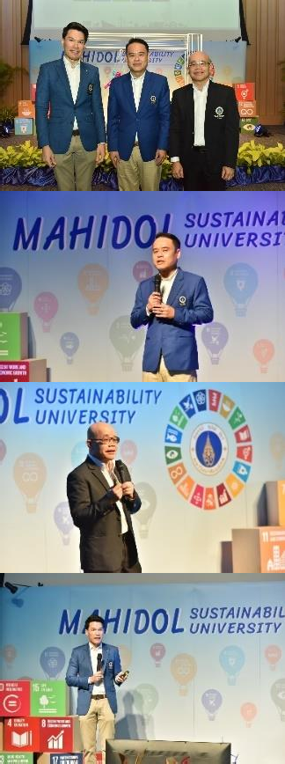
4. | 2 December  2020 | Mahidol Sustainable Development Goals Conference 2020 | Mahidol Sustainable  Development Goals Conference 2020 was honored by Clinical Prof. Emeritus Piyasakol Sakolsatayadorn, M.D., the Chairman of Mahidol University Council, Prof. Banchong Mahaisavariya, M.D., the President of Mahidol University and Assoc. Prof. Kitikorn Charmondusit, Ph.D., the Vice President for  Environment and Sustainable Development, Mahidol University, respectively to be the keynote speakers. There were participated more than  70 staffs in Mahidol Learning Center and more than 440 has watched on Facebook Mahidol | 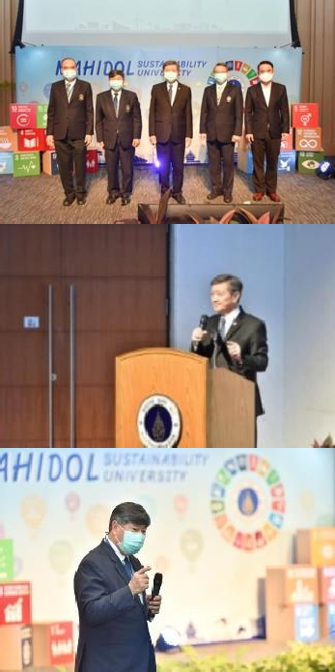

No. | Date | Activity | Report | Photo
 |  |  | University Sustainability fan page. Moreover, there are 15 persons presented academic papers in the form of online oral presentation via Cisco Webex application. | 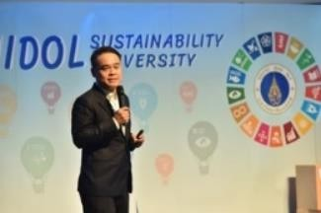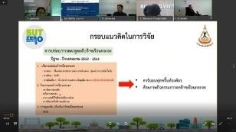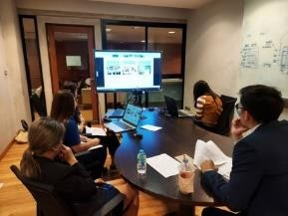
5. | 3-4  December 2020 | The 5th Annual Conference of Sustainable University Network of Thailand 2020 at King Mongkut’s University Technology Thonburi, Bangkhuntien Campus. | Assoc. Prof. Kitikorn Charmondusit, Ph.D., the Vice President for  Environment and Sustainable Development, Mahidol University, Thailand as a representative of Mahidol University attended the 5th Annual Conference of Sustainable University Network of Thailand 2020. In addition, Mahidol University students participated in the student project challenge and also received an award from this competition. | 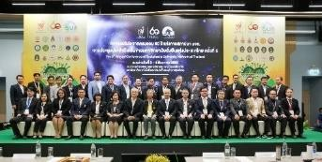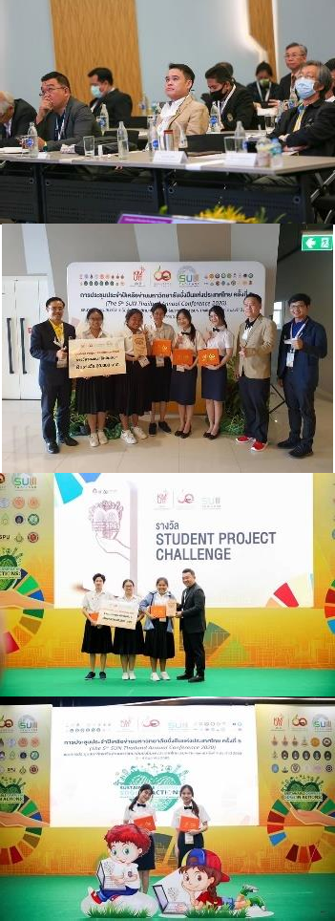

No. | Date | Activity | Report | Photo
6. | 25 May  2021 | The Implementatio n on Mahidol Eco University and Sustainability Policy | The Implementation on Mahidol Eco University and Sustainability Policy is aim to build knowledge and understanding of the Sustainable Development Goals and to prepare the faculties to drive the university towards the Sustainable Development Goals.  Assoc. Prof. Kitikorn Charmondusit, Ph.D.the Vice President for  Environment and Sustainable Development, Mahidol University, Thailand presented in the topic “Mahidol Eco University and  Sustainability Policy” to be a guideline for faculties can implement according to the university’s guidelines. There are more than 140 participants attended. | 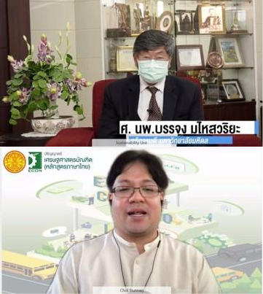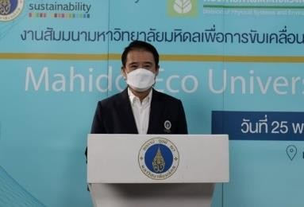
7. | 19 May  2021 | World Environment Day 2021:  Ecosystem Restoration | The theme of world environment day in this year is “Restoration Ecosystem”. To achieve the eco- university policy, division of Physical systems and Environment, Mahidol University organized tree planting activity at Mahidol University Library and Knowledge Center on May 19, 2021 by the practice of social distancing. There are  28 participants from 25 faculties. | 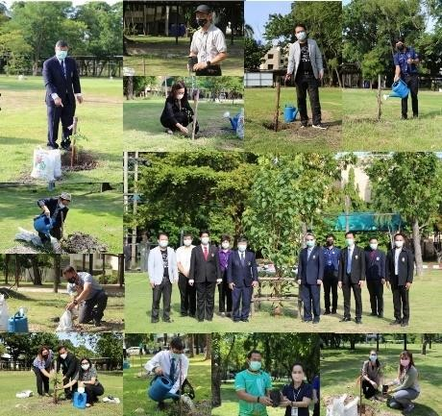

No. | Date | Activity | Report | Photo
8. | 2 June 2021 | World Environment Day 2021:  Plant-based online symposium | Plant-based online symposium was held by Mahidol University to disseminated the knowledge on sustainable consumption, which is good for health and the earth. This activity was honored by experts on nutrition, health, sustainable agriculture. This online symposium published on Facebook Live Mahidol University Sustainability fan page which has more than 3,000 views. | 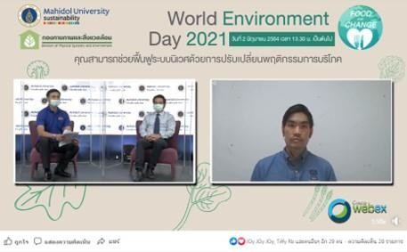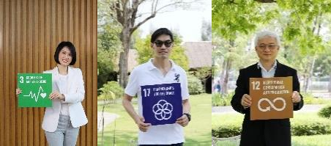
9. | 9 June 2021 | Circular Economy: GC x Mahidol Webinar 2021 | Mahidol University collaborate with PTT Global Chemical Public Company Limited organized online symposium on Circular Economy and Sustainability for Higher Education to share interesting perspectives and commitment to drive a circular economy into reality, whether adaptability and opportunity in resilience development, behavior change on campus and so on. This online symposium was honored by keynote speakers from Thailand and abroad, there are more than 250 participants attended through Cisco Webex application and Facebook Live on Mahidol University Sustainability fan page. | 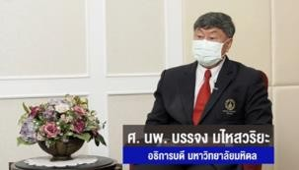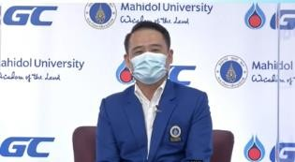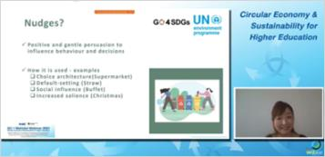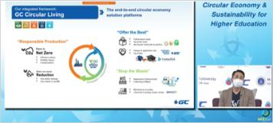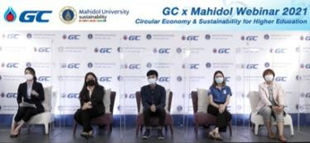

No. | Date | Activity | Report | Photo
10. | 1 June-31 October 2021 | Circular Economy: YOUturn Platform | Mahidol University cooperates with PTT Global Chemical Public Company Limited to launch the YOUturn platform for managing used plastics from the collection and sorting of waste, transporting plastic waste into the system recycling process and processing until it is turned into an upcycling product, which is a product that has added value once again. This platform can bring more than 8,000 used plastic bottles, which receive from donation to produce polo t-shirt for sale, the proceeds after deducting expenses will be donated to provide medical equipment to fight with COVID-19. | 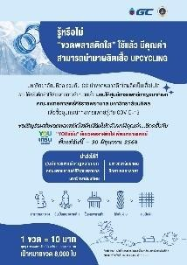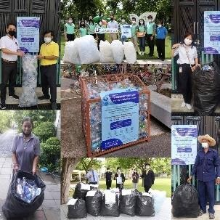
11. | 30 June  2021 | Innovation for Sustainability Campus: SDGs smart action 2021 | Innovation for Campus Sustainability Project is an activity contest for all student to design or create of an innovation towards sustainable university. The project aims to find the best innovation that apply the knowledge of sustainable development on three aspects including economic, social and environment and to strengthen Mahidol students to be a person who has creativity for innovation which align with Thailand  4.0. There are eight student teams attended but only four student teams were qualified in the proposal presentation  round. | 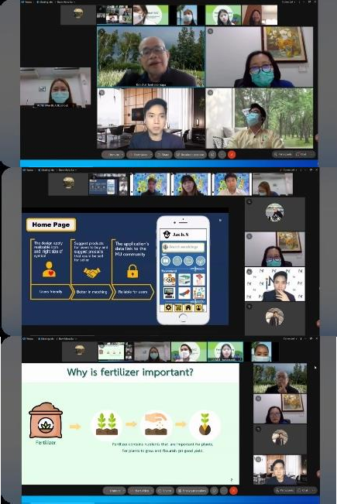

No. | Date | Activity | Report | Photo
12. | 23 July  2021 | The 2nd National Workshop of UI  GreenMetric for University in Thailand | Mahidol University organized “The 2nd Nation Workshop of UI GreenMetric for University in Thailand” online symposium via Cisco Webex application, Facebook live on Mahidol University Sustainability fan page. This online symposium aims to enhance sustainable development in higher education and to share current management experience in sustainable development among the universities. There are more than 85 participants from Thai universities attended.  This webinar was honored by the representative keynote speakers of Mahidol University, Thailand  ,including Prof. Banchong Mahaisavariya, M.D., the President of Mahidol University presented in the topic “Sustainability in Higher Education” and Assoc. Prof. Kitikorn Charmondusit, Ph.D., the Vice President for  Environment and Sustainable Development, Mahidol University presented in the topic “The result comparison of UI GreenMetric World University Rankings in Thailand”. | 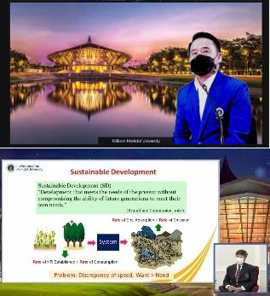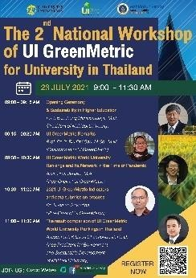

No. | Date | Activity | Report | Photo
13. | 2 August  2021 | Leadership for Sustainable Development Workshop | Mahidol University recognizes the importance of sustainable development, therefore, training workshop on leadership for sustainable development was organized. This workshop aims to raise awareness on the United Nations Sustainable Development Goals, to prepare and create the leadership in driving Mahidol University towards sustainable development and to be able to adjust activity plan management both in the short and long term. This workshop was attended by executive level of Mahidol University more than 80 persons. | 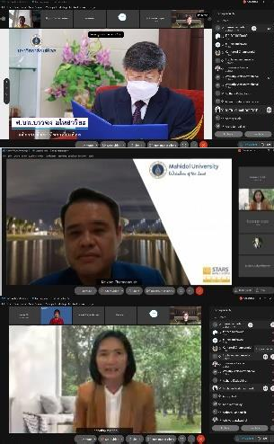

- Challenges and Future Plans
- The 5th Steering Committee (Virtual) Meeting UI GreenMetric World University Rankings Network.
- The 7th International (Virtual) Workshop on UI GreenMetric World University Rankings (IWGM 2021).
- Mahidol University Sustainability Week 2021: Actions towards Sustainability Goals.
- Leadership for Sustainable Development Workshop with students and communities around Mahidol University.
- Driving the university towards Sustainable Development.
- Collaboration with the partner universities around the world and international network.
- Promote sustainable development in Thai higher education institutions.

Comments
None

Prepared by Assoc. Prof. Kitikorn Charmondusit, Ph.D.
Vice President for Environment and Sustainable Development

