Journal of Sustainability Perspectives edition, year, pages | Journal of Sustainability Perspectives  journal homepage: https://ejournal2.undip.ac.id/index.php/jsp/ | 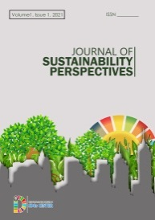

Title of The Article Related to Sustainability Perspective Relating to Natural Sciences, Medical and Public Health, Engineering and Technology, Social Sciences and Humanities, Economy And Business

Author¹, Author²* etc
¹Department, Institution, Position/Job Description, Address, Country/State
² Department, Institution, Position/Job Description, Address, Country/State
*corresponding author: email

Article Info | Abstract. The abstract should state briefly the purpose of the research, the principal results and major conclusions. An abstract is often presented separately from the article, so it must be able to stand alone. For this reason, References should be avoided. Also, non-standard or uncommon abbreviations should be avoided, but if essential they must be defined at their first mention in the abstract itself. Abstract should commence with a clear and short introduction mentioning background of research. Subsequently, state the general problem of the research, followed by results/main findings that directly answer the problem. Give one or two sentence(s) to discuss the finding(s) or prospective(s).  Keyword: (for instance, there are 2 to 8 keywords)  Sustainable transport, sustainable mobility, low-emission vehicles, remote working
Received:
XX Month XXXX
Accepted:
XX Month XXXX
Published:
XX Month XXXX

DOI:

Presented in the 9th International Workshop on UI GreenMetric World University Rankings (IWGM 2023)

- Introduction
State the objectives of the work, research problem and provide an adequate background. Give a description of the studied object(s). No need to give sub point of introduction. It may include the part of the citation by giving number [1], [2], [3], and so on. It could also provide sufficient detail of materials used and method done to allow the research to do.
- Points of Results and Discussions
Results should be clear and concise. State the obtained results After mention the results of the work, discuss your data by describing the argumentation, or comparing the current reported data with previous results, but avoid extensive citations and discussion of published literature. It may include the part of the citation by giving number [1], [2], [3], and so on.

  - Sub-point of results and discussions
………
  - Sub-point of results and discussions
………

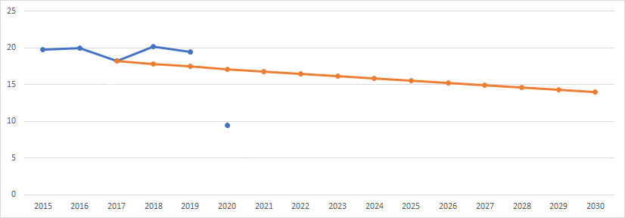
Figure 1. The title or short description of the figure/graphics

Table 1. The title or short description of the tables
 | 1. Reduce |  | 2. Switch |  | 3. Green
Reducing transport movements:  - Sharing cars  - Carpooling  - Flexible working (HNW - the new working method)  - Teleworking  - Video conferencing  - Smart flying (combination)  - Combining goods traffic  Reducing distance:  - Living closer to work  Purchasing locally |  | Transport alternatives:  - Mobility management  - Mobility budget  - Financial incentives: Public transport and bicycle  - Substantially improving public transport options  - Clean two-wheeled vehicles (e-bikes/scooters) |  | Cleaner transport:  - Electric cars  - Green gas  - Hydrogen  - Sustainable fuel blend  - Fuel-efficient cars  - Zero emissions  Efficiency:  - Improving traffic flow  - Less traffic  - The new driving method  Optimal tire pressure

- More Points of Results and Discussions (if necessary)
  - Sub-points of results and discussions
………

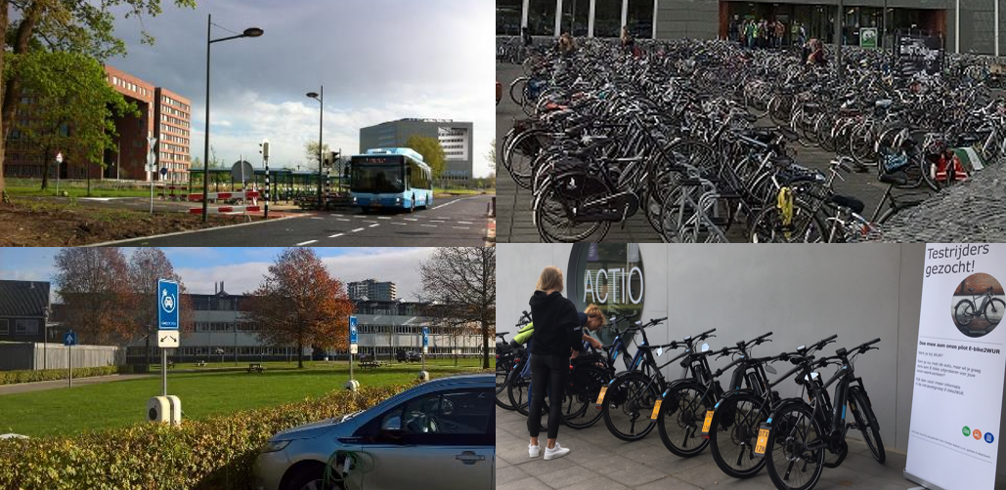
Figure 2. The title or short description of the figure or graphics

  - Sub-points of results and discussions
…………

- Conclusion or Concluding remarks
You may conclude of your writing in this part by giving conclusion of the discussion in short and concise sentence, or make summary of your discussion. Please not to rewrite any part of introduction or materials and method or result and discussion.

References (respecting to citation in discussions or introduction)
- WUR, Strategic Plan 2019-2022 (2019). Available online at https://www.wur.nl/en/About-Wageningen/Strategic-Plan.htm (direct link), accessed on 29 July 2021
- WUR, Mobility Plan 2030. Sustainable mobility at Wageningen University & Research (2019). Available online at https://www.wur.nl/en/About-WUR/Sustainability/Operational-management/Show/Mobility.htm (direct link), accessed on 2 August 2021
- Kennisinstituut voor Mobiliteitsbeleid, Fietsfeiten: nieuwe inzichten (2020). Available online at https://www.kimnet.nl/publicaties/brochures/2020/10/12/fietsfeiten-nieuwe-inzichten, accessed on 9 August 2021
- DTV Consultants, Mobiliteitsonderzoek voor Wageningen UR 1-meting (december 2015): de resultaten (2016). Internal document
- Etc.

