Journal of Sustainability Perspectives x (x), 20xx, xx-xx | Journal of Sustainability Perspectives  journal homepage: https://ejournal2.undip.ac.id/index.php/jsp/ | 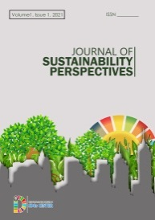

Title (Capitalize Each Word, Calibri, 18pt, spacing 1)

Author name*¹, Author name ², Author name ³ (Calibri, 12 pt, italic)
¹Institution, Country (Calibri, 10 pt, italic)
²Institution, Country (Calibri, 10 pt, italic)
³Institution, Country (Calibri, 10 pt, italic)
*corresponding author: email (Calibri, 10pt)

Article Info | Abstract. The abstract title is written in Calibri style (14 pt and bold). The body text of the abstract was written Calibri style (10 pt). An abstract should inform the prospective reader of what you did and highlight the key findings. Avoid using technical jargon and uncommon abbreviations. The abstract should be clear, concise, and descriptive. Abstracts at least include research background (not mandatory except in the field of health sciences), study objectives, brief methods, brief findings, and brief conclusions. The abstract should end with a comment on the significance of the results or a brief conclusion. Please follow word limitations (100‐300 words).  Keyword:  Keywords written under the abstract text are arranged in alphabetical order and separated by a comma. Title keywords are written with Calibri style with 14 pt bold font while the keywords written with Calibri 10 pt.
Received:
xx Month xxx
Accepted:
xx Month xxx
Published:
xx Month xxx

DOI:

Presented in the 10th International Workshop on UI GreenMetric World University Rankings (IWGM 2024)
- Introduction
The introduction must contain the state of the art from previous studies, there is a gap analysis/gap analysis/statement of novelty/statement of contribution to the novelty of the article.
Journal Of Sustainability Perspectives (JSP) is a cross-disciplinary scholarly, open-access journal of human beings' environmental, cultural, economic, and social sustainability, providing an advanced forum for studies related to sustainability and sustainable development. it publishes reviews, regular research papers (original articles), communications, and short notes. Journal Of Sustainability Perspectives is published by SDGs Center Universitas Diponegoro[1].

- Theoretical Approach/Methodology/Scenario
General Instructions
Articles should be written on A4 paper (210 x 297 mm). Articles are written without page numbers and arranged in the following order: Title, Abstract, Keywords, Introduction, Theoretical Approach/Methodology/Scenario, Results/Discussion/implementation, Conclusions / Summary/ Future Perspectives, Acknowledgments (if any), Notation List (if any) and References.

Writing Guidelines
The article begins with the title of the article written in font Calibri, 18 pt bold. The title is an opportunity to attract the reader’s attention. Remember that readers are the potential authors who will cite your article. Identify the main issue of the paper. The title should be accurate, unambiguous, specific, and complete. Do not contain infrequently-used abbreviations.
The author's name is written under the title in font Calibri, 12 pt italic. The author's name is written completely without an academic degree. Apostrophes are written behind the author's name in superscript format. The name of the institution (institution, and country) is written under the author's name with the theme of Calibri 10 pt, italic. If the author is more than one, should be a written email for the correspondence author (corresponding author). The article title, author's name, and institutional name are written flat center.
The contents of the article are written with a left margin of 2,54 cm, a right margin of 2,54 cm, a bottom margin of 2,54 cm, and a top margin of 2,54 cm. The header distance from the edge of the paper is 1,25 cm, and the footer distance from the edge of the paper is 1,25 cm. Articles are written in MS Word program with Calibri font type, 12 pt font, 1 space, and in one column format written justified.
Subtitles are written in bold with Capitalize Each Word format and arranged to align left with a number and no underscore. Sub subtitles are written in bold with Sentence case format and arranged to align left with no number and underscore.

- Results/Discussions/Implementation
Figures and Tables
Figures and Tables are placed in groups of text and annotated. The figure is followed by the caption placed under the figure and the table is followed by the caption placed on the table. The figures and the tables are numbered. The figure is guaranteed to be printed clearly even though it is reduced to 50%. The figure is not framed. Tables with no vertical lines, whereas horizontal lines are only shown in 3 main horizontal lines i.e., 2 horizontal lines for the column headings and 1 closing line for the bottom row.
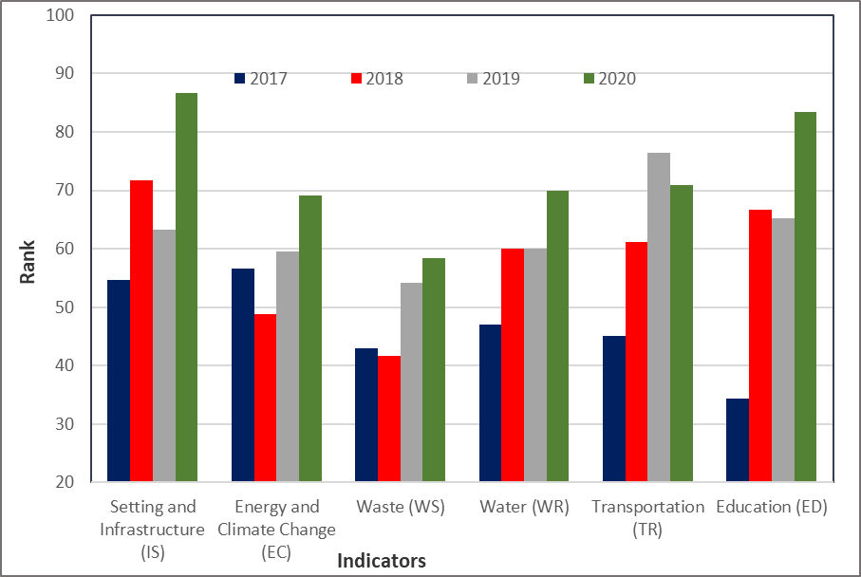
Figure 1. University of Babylon rank for each indicator (2017-2020)

Table 1. Quantity of Solid Waste Generated
S.No. | Name of the waste material | Weight (kg/day)
1 | Plant Residue | 692
2 | Vegetable Waste | 290
3 | Wood Materials | 43
Total |  | 1025

Equations
The equations are written center and numbered in parentheses. The number is placed at the end of the right margin of the column.
$D=\frac{A}{{\left(V_{rel}^{2}ρ_{a}\right)}^{2}}+B{\left(\frac{M_{air}}{M_{liq}}\right)}^{-β}$ (1)

Quote Writing
The writing system quotes a manuscript or literature using the Vancouver system. Examples: These results clearly indicate that the University of Babylon is moving at a steady and confident pace in order to achieve its vision, mission, and goals outlined in its strategic plan for 2018-2022 [1]

- Conclusions/Summary/Future Perspectives
Conclusions/Summary/Future Perspectives should only answer the objectives of the research. Tells how your work advances the field from the present state of knowledge. Without clear Conclusions/Summary/Future Perspectives, reviewers and readers will find it difficult to judge the work, and whether or not it merits publication in the journal. Do not repeat the Abstract, or just list experimental results. Provide a clear scientific justification for your work, and indicate possible applications and extensions. You should also suggest future experiments and/or point out those that are underway. Conclusions/Summary/Future Perspectives may not use bullets and numbering.

References
References are listed with numbers.
1. Stagnaro-Green A, Abalovich M, Alexander E, Azizi F, Mestman J, Negro R, et al. Guidelines of the American Thyroid Association for the Diagnosis and Management of Thyroid Disease During Pregnancy and Postpartum. Thyroid. 2011 Oct;21(10):1081–125.
2. Ece A, Uyamik BS, IŞcan A, Ertan P, Yiğitolu MR. Increased serum copper and decreased serum zinc levels in children with iron deficiency anemia. Biol Trace Elem Res. 1997 Dec;59(1–3):31–9.

